**Thursday Bingo Is Back!!**

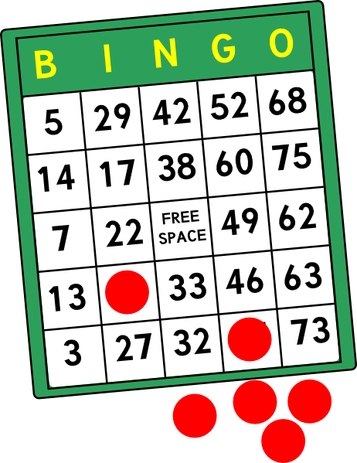

* **Over $1,200 in Cash Prizes**
* **Amazing Door Prizes**
* **Free Coach Bag Giveaway**
* **Instant Winners**
* **Free Delicious Dinner**
* **Lots of Fun & Excitement**

**Knights of Columbus BINGO EVERY THURSDAY**

**January 5 to March 30, 2023**

**Doors open at 5:30 pm**

**(Games run 7pm-9pm)**

**San Marco Catholic Church**

**Parish Center**

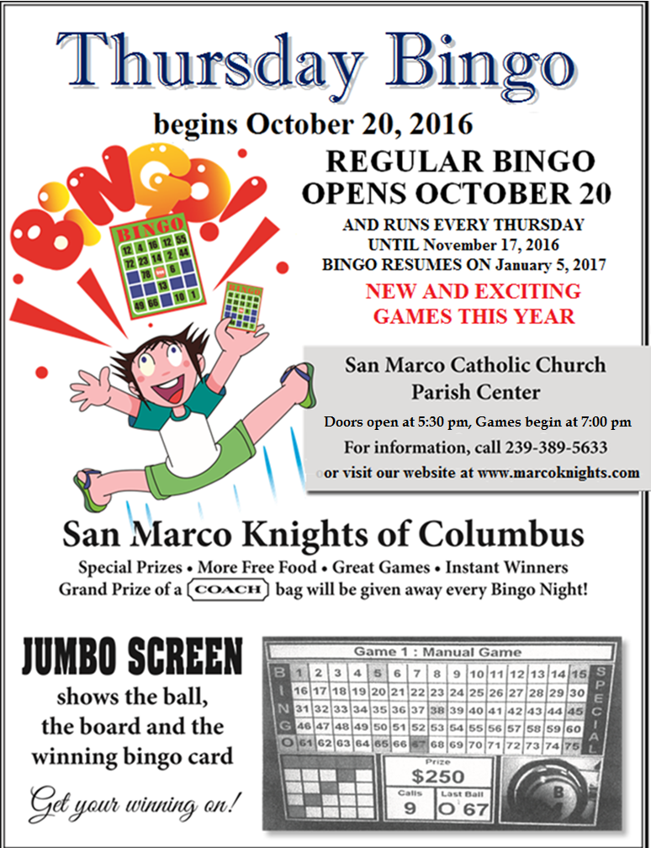

**We thank you for your support. Proceeds fund our annual giving programs to local charities such as Catholic Education, College scholarships for parish children, St. Vincent DePaul Society, Our Daily Bread Food Pantry, and many other wonderful charitable organizations.**

**For more information call (239) 389-5633 or www.sanmarcoknights.com**